Chapter 10, Solution 39.

For mesh 1,
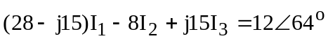 (1)
For mesh 2,

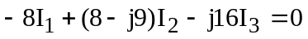 (2)
For mesh 3,

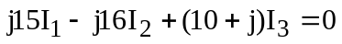 (3)

In matrix form, (1) to (3) can be cast as

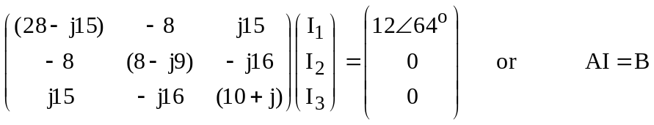

Using MATLAB,

I = inv(A)*B

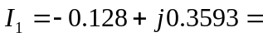 381.4∠109.6° mA
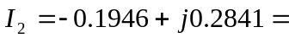 344.3∠124.4° mA
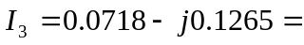 145.5∠–60.42° mA
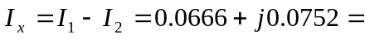 100.5∠48.5° mA

381.4∠109.6° mA, 344.3∠124.4° mA, 145.5∠–60.42° mA, 100.5∠48.5° mA

